The official design document for Better Curve; the best deck building tool ever built.

Better Curve

Week One

Kevin Manning

CS 240 – Android Apps

Contents

Revision History 2

Introduction 3

Analysis 4

Prioritized use cases 4

# Revision History

|  |  |
| --- | --- |
| 1/5/16 | * Documentation   + Created Document   + Added Cover Sheet   + Added Table of Contents   + Added section for Revision History |
| 1/9/16 | * Documentation   + Added Use Case #1   + Added Document Description   + Added Introduction |
|  |  |
|  |  |
|  |  |
|  |  |
|  |  |
|  |  |

# Introduction

Better Curve is a powerful, all-in-one tool for building decks for various TCGs. With pre-loaded games, the user can simply build their deck obeying the rules of the game. For one not yet added, the user can simply define a few quick rules and from there construct the deck. Afterwards, this powerful app calculates percentages for drawing cards based on the turn the resources to use them becomes available, allowing players to fine tune decks right from the builder.

# Analysis

### Prioritized use cases

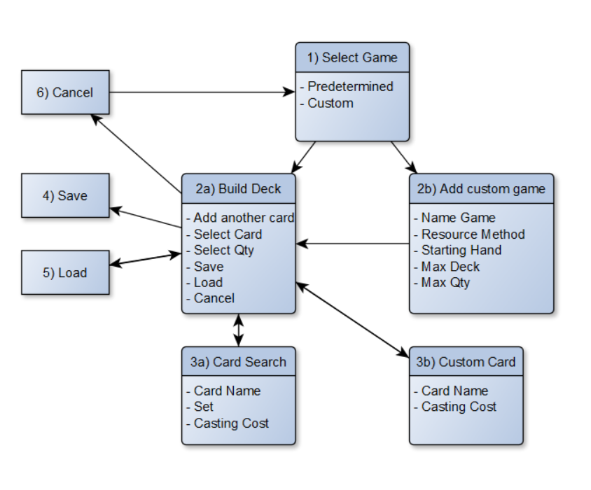

1. The home screen, shows user created decks and provides options for creating new decks, modifying/removing existing decks, or viewing stats.
2. (If New Deck) The user will be able to select which game they want to make a deck for, or create a custom set of rules.
3. The user can add to or remove cards from their deck.
4. The user will be able to select a card from that game (or enter some basic info for a custom game)
5. The user will be able to save the current deck, being prompted to name it.
6. The user can load a previously created deck.
7. The user can also choose to cancel, without saving, at any time.
8. The user will see updated statistics of their decks curve.
9. The user can return to the home screen.